Jon Janelle

MAT 500

9/23/13

**Chapter 5 Homework**

**5.2**

**(A)** Let $θ$ represent the proportion of voters that prefer candidate A. If our prior beliefs are modeled by a uniform distribution, then they can be expressed as $p\left(θ\right)=Beta\left(θ|1,1\right)$.

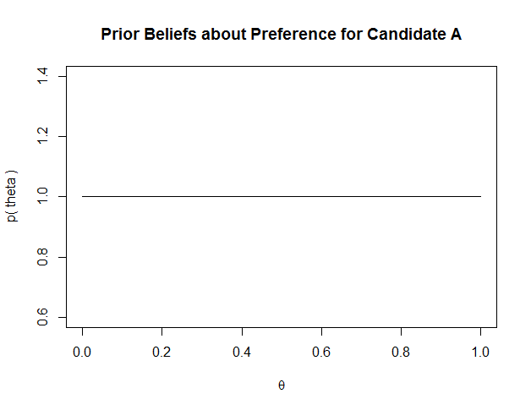

Since the number of people sampled is N = 100 and the number of people preferring candidate A is Z = 58, the the posterior distribution for $θ$ is $Beta\left(Z+1, N-Z+1\right)=Beta\left(θ | 59, 43\right).$

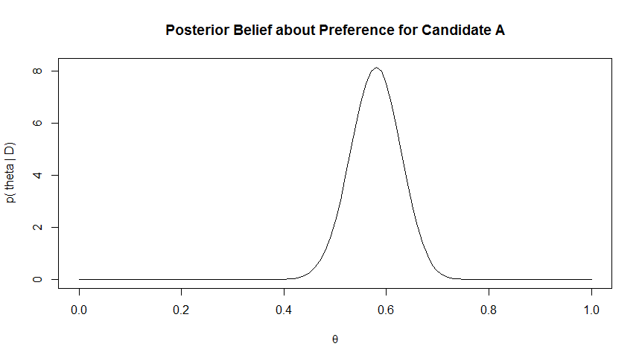

The 95% HDI for our beliefs about the preference for candidate A given the newspaper poll data is **(0.482, 0.672)**. This result was obtained using qbeta(c(0.025, 0.975), 59, 43) in R.

**(B)** It is credible to believe that the population is equally divided in its preferences because $θ=0.5$ lies in the 95% HDI calculated in part A.

**(C)** Using the posterior found in part A, our prior belief about the proportion of voters that prefer candidate A is now $p\left(θ\right)=Beta\left(θ|59,43\right)$. N = 100 is the size of the new poll taken, and Z = 57 is the number of people in the poll who prefer candidate A.

Given this new poll, our posterior belief, $p\left(θ | D\right),$ is $Beta\left(θ | 116,86\right).$ The 95% HDI for the posterior distribution is **(0.506, 0.642).**

**(D)** After the follow up poll, we cannot conclude that it is credible to believe that the population is equally divided in its preferences amount candidates because $θ=0.5$ is outside of the 95% HDI calculated in part C. After the second poll, we conclude that there is a greater preference for candidate A.

**5.3**

Let $θ$ represent the proportion of people who choose F. In both cases, let our prior beliefs about $θ$ be modeled by the uniform distribution $p\left(θ\right)=Beta(θ|1,1)$.

First the case of the word “radio” by itself will be considered. The sample size was N = 50, and Z = 40 people chose F. Thus, the posterior distribution for $θ$ is $p\left(θ|D\right)=Beta(θ|41,11)$. The 95% HDI for this posterior is (0.669, 0.887). Since $θ=0.5$ is not in the HDI and the HDI lies entirely above $θ=0.5$, we conclude that people are biased toward pushing F when only the word “radio” is shown.

In the second case the words “ocean” and “mountain” were shown together. The sample size was N = 50, and Z = 15 people chose F. The posterior distribution for $θ$ is therefore $p\left(θ|D\right)=Beta(θ|16,36)$. The 95% HDI for this posterior is (0.191, 0.438). Since $θ=0.5$ is not in the HDI and the HDI lies below $θ=0.5$, we conclude that people are biased toward J in their responses in this case.

**5.6**

Let $θ$ represent the probability of a heads flip. We wish to determine if the coin is more likely to be fair or trick based on a sample of N = 20 flips where Z = 15 landed heads. Two priors, one which assumes a fair coin an one that assumes a trick coin, will be used.

The prior for the fair coin model, M1, is $p\left(θ\right)=Beta(θ|100,100)$. This models fairness as a situation where a coin is flipped 200 times and lands heads 100 times. Using this prior, the expected value for $θ$ is 0.5, which indicates a heads flip is believed to be equally as probable as a tails flip. The 95% HDI for $p\left(θ\right)$ is (0.431, 0.569), which shows a high level of certainty that $θ=0.5$ is a credible belief. The graph of this prior below confirms that it reflects a strong belief in the coin’s fairness because it is symmetric and narrowly distributed about $θ=0.5$.

The prior for the trick coin model, M2, is $p\left(θ\right)=Beta(θ|0.5,0.5)$. As the graph shows, this model expresses the belief that the coin is either strongly biased in favor of either heads or tails.

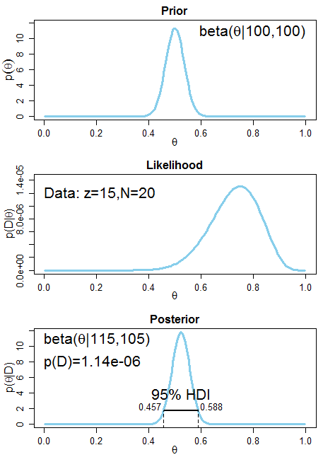 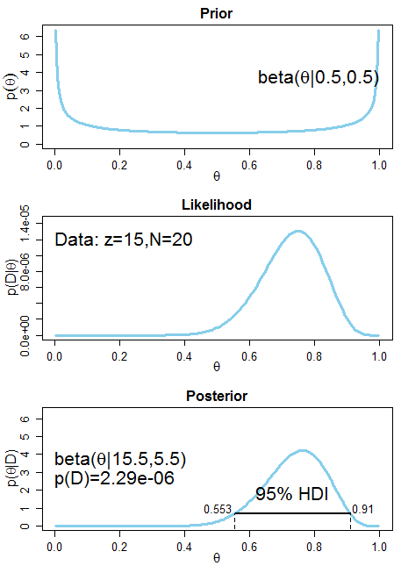

Trick Coin Model (M2)

Fair Coin Model (M1)

From the values of P(D) shown on the posterior graphs, we see that $P\left(D | M1\right)<P(D|M2)$, which means that Bayes factor $\frac{P\left(D | M1\right)}{P(D|M2)}$ is less than 1. The conclusion is that we believe the coin is more likely to be a trick coin than a fair coin since the observed data are more likely given model 2.

**5.8**

**(A)** Let $θ$ represent the probability of flipping a heads. $Beta(θ|1,100)$ is a model for a strong prior belief that the coin is strongly biased towards tails, and $Beta(θ|100,1)$ is a model for a strong prior belief that the coin is strongly biased toward heads. In a sample of N = 12 flips, z = 8 are heads.

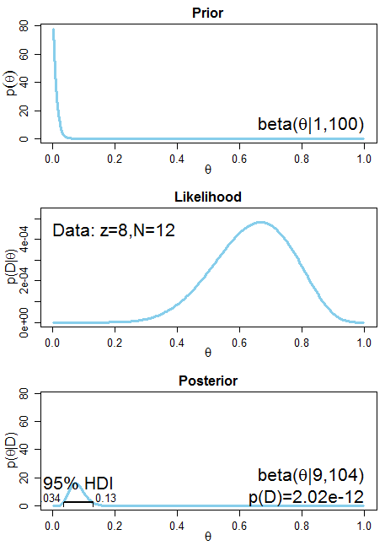 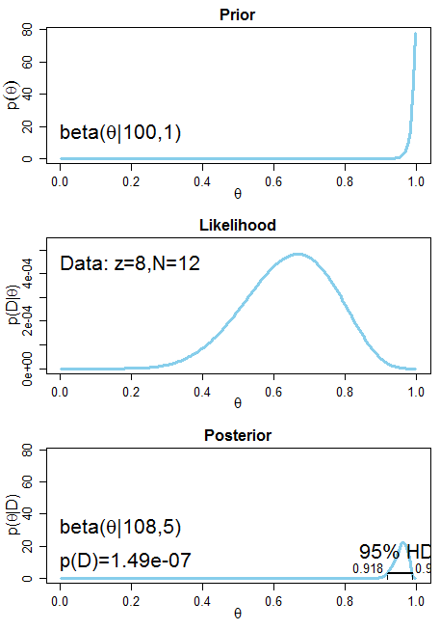

Tails Biased Model (M1)

Heads Biased Model (M2)

Bayes factor is $\frac{P\left(D | M1\right)}{P(D|M2)}=\frac{2.02×{10}^{-12}}{1.49×{10}^{-7}}=1.36×{10}^{-5}$. Since this is far less than 1, the heads-biased model M2 is much more likely given the data. M2 may also be a poor fit, but it is superior to M1.

**(B)** On line 12 of the code, the statement nSimSamples = 10000 sets the number of simulated samples to 10000. The size of each sample is N = 12, which is set on line 10.

**(C)** A different value of $θ$ is used to generate each sample and is selected pseudo-randomly from the posterior distribution. This is done so that the samples generated will well-represent the posterior distribution for M2. If the same value of $θ$ were used each time, then there would be a much greater risk that an extreme value of $θ$ would be randomly chosen that would lead to results that are not representative of the posterior distribution. The value of theta is generated on line 18 with the statement sampleTheta = rbeta( 1 , postA , postB ).

**(D)** The winning model does not appear to be a good fit based on the simulation results.

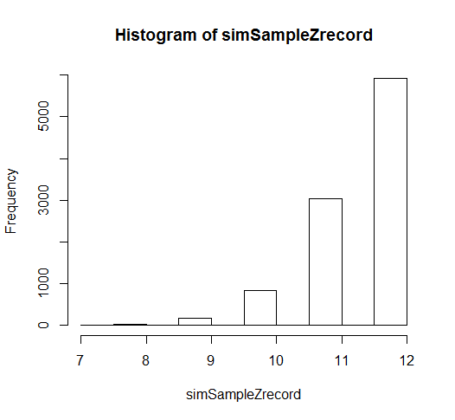

|  |  |  |  |  |
| --- | --- | --- | --- | --- |
| Number of Heads | 9 | 10 | 11 | 12 |
| Proportion of Samples | 0.0176 | 0.0829 | 0.3027 | 0.5930 |

As the table shows, 99.62% of the samples generated contained 9 or more heads, and therefore it is highly unlikely that the model is a good fit for the coin given that 8 heads were observed.